Name - **Atharva Suhas Chavan**Class - TE A  
Roll no - T1851010   
PRN - 71901316L  
Seat no: **T150088526**

Title: **Date and time functions**

**Code:  
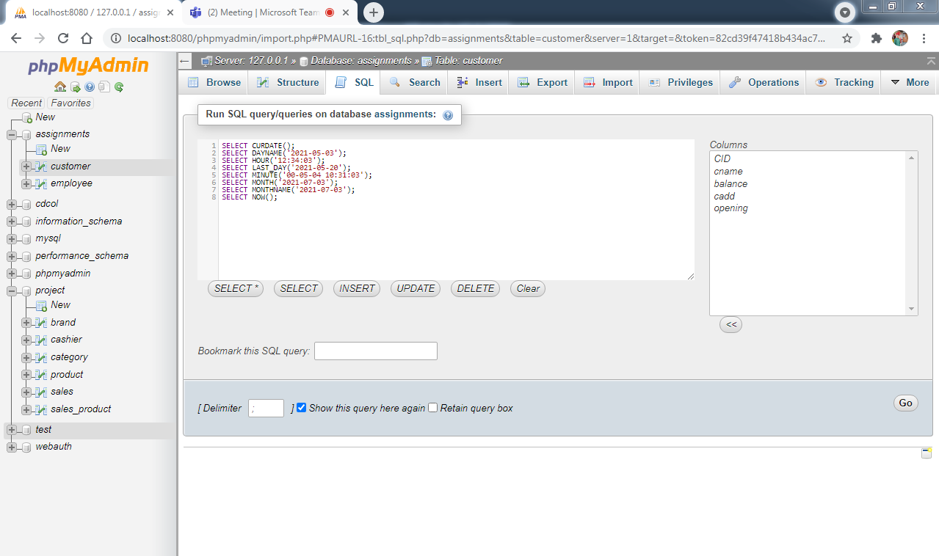**

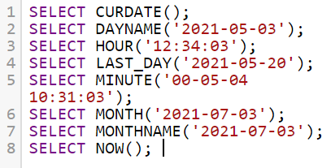

**Output:**

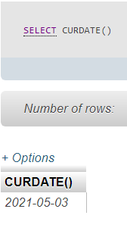

SELECT CURDATE(); : Returns the current date

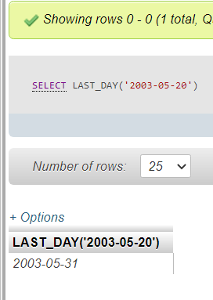

SELECT LAST_DAY('2003-05-20'); : Returns the value for the last day of the month

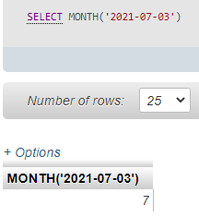MONTH(date): Returns the month for date, in the range 0 to 12.

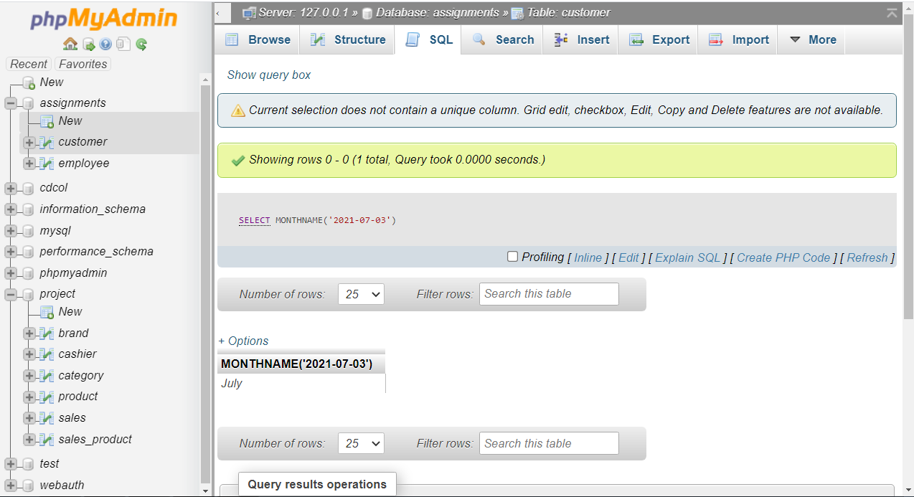

MONTHNAME(date); : Returns the full name of the month for date.

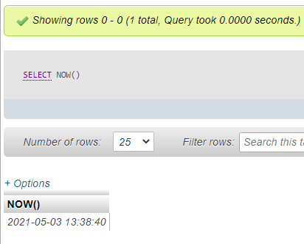SELECT NOW(); : Return current date and time